Project Planning Phase

**Project Planning Template (Product Backlog, Sprint Planning, Stories, Story points)**

|  |  |
| --- | --- |
| Date | 25 October 2022 |
| TeamID | PNT2022TMID13271 |
| ProjectName | Fertilizer Recommendation System for Disease Prediction |
| MaximumMarks | 8 Marks |

Product Backlog, Sprint Schedule, and Estimation (4 Marks)

|  |  |  |  |  |  |  |
| --- | --- | --- | --- | --- | --- | --- |
| **Sprint** | **Functional**  **Requirement(Epic)** | **User Story Number** | **User Story/Task** | **Story**  **Points(Total)** | **Priority** | **Team Members** |
| Sprint-1 | Model Creation and Training (Fruits) |  | Create a model which can classify diseased fruit plants from given images. I also need to test the model and deploy it on IBM Cloud | 8 | High | M.Jeevamukesh,A.Aravinth, M.Kalimuthu Madasamy, V.Muthukumar, M.Muthuraj |
|  | Model Creation and Training (Vegetables) |  | Create a model which can classify diseased vegetable plants from given images | 2 | High | M.Jeevamukesh,  A.Aravinth, M.Kalimuthu Madasamy, V.Muthukumar, M.Muthuraj |

|  |  |  |  |  |  |  |
| --- | --- | --- | --- | --- | --- | --- |
| **Sprint** | **Functional Requirement**  **(Epic)** | **User Story Number** | **User Story/Task** | **StoryPoints**  **(Total)** | **Priority** | **Team Members** |
| Sprint-2 | Model Creation and Training (Vegetables) |  | Create a model which can classify diseased vegetable plants from given images and train on IBM Cloud | 6 | High | M.Jeevamukesh,  A.Aravinth, M.Kalimuthu Madasamy, V.Muthukumar, M.Muthuraj |
|  | Registration | USN-1 | As a user, I can register by entering my email ,password, and confirming my password or via OAuth API | 3 | Medium | M.Jeevamukesh,  A.Aravinth, M.Kalimuthu Madasamy, V.Muthukumar, M.Muthuraj |
|  | Upload page | USN-2 | As a user, I will be redirected to a page where I can upload my pictures of crops | 4 | High | M.Jeevamukesh,  A.Aravinth, M.Kalimuthu Madasamy, V.Muthukumar, M.Muthuraj |
|  | Suggestion results | USN-3 | As a user,I can view the results and then obtain the suggestions provided by the ML model | 4 | High | M.Jeevamukesh,  A.Aravinth, M.Kalimuthu Madasamy, V.Muthukumar, M.Muthuraj |
|  | Base Flask App |  | A base Flask web app must be created as an interface for the ML model | 2 | High | M.Jeevamukesh,  A.Aravinth, M.Kalimuthu Madasamy, V.Muthukumar, M.Muthuraj |
| Sprint-3 | Login | USN-4 | As a user/admin/shopkeeper, I can login to the application byentering email & password | 2 | High | M.Jeevamukesh,  A.Aravinth, M.Kalimuthu Madasamy, V.Muthukumar, M.Muthuraj |
|  | User Dashboard | USN-5 | As a user, I can view the previous results and history | 3 | Medium | M.Jeevamukesh,  A.Aravinth, M.Kalimuthu Madasamy, V.Muthukumar, M.Muthuraj |
|  | Integration |  | Integrate Flask,CNN model with CloudantDB | 5 | Medium | M.Jeevamukesh,  A.Aravinth, M.Kalimuthu Madasamy, V.Muthukumar, M.Muthuraj |
|  | Containerization |  | Containerize Flask app using Docker | 2 | Low | M.Jeevamukesh,  A.Aravinth, M.Kalimuthu Madasamy, V.Muthukumar, M.Muthuraj |

|  |  |  |  |  |  |  |
| --- | --- | --- | --- | --- | --- | --- |
| Sprint-4 | Dashboard (Admin) | USN-6 | As an admin, I can view other user details and uploads for other purposes | 2 | Medium | M.Jeevamukesh,  A.Aravinth, M.Kalimuthu Madasamy, V.Muthukumar, M.Muthuraj |
|  | Dashboard (Shopkeeper) | USN-7 | As a shopkeeper,I can enter fertilizer products and then update the details if any | 2 | Low | M.Jeevamukesh,  A.Aravinth, M.Kalimuthu Madasamy, V.Muthukumar, M.Muthuraj jaya  prakash. |
|  | Containerization |  | Create and deploy Helm charts using Docker Image made before | 2 | Low | M.Jeevamukesh,  A.Aravinth, M.Kalimuthu Madasamy, V.Muthukumar, M.Muthuraj |

Project Tracker, Velocity & Burndown Chart:(4 Marks)

|  |  |  |  |  |  |  |
| --- | --- | --- | --- | --- | --- | --- |
| **Sprint** | **Total Story Points** | **Duration** | **Sprint Start Date** | **Sprint End Date(Planned)** | **Story Points Completed (as on**  **Planned End Date)** | **Sprint Release Date (Actual)** |
| Sprint-1 | 10 | 6Days | 24Oct2022 | 29Oct2022 | 10 | 30Oct2022 |
| Sprint-2 | 15 | 6Days | 31Oct2022 | 05Nov2022 | 15 | 06Nov2022 |
| Sprint-3 | 15 | 6Days | 07Nov2022 | 12Nov2022 | 15 | 13Nov2022 |
| Sprint-4 | 12 | 6Days | 14Nov2022 | 19Nov2022 | 10 | 20Nov2022 |

***NOTE: Burndown charts,Velocity to be updated dynamically after end of sprints***

Roadmap:

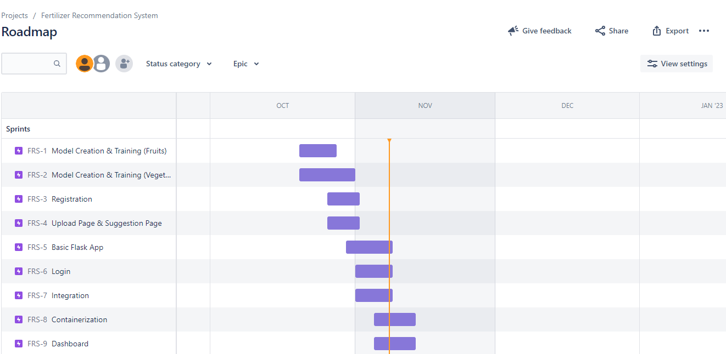

Screenshots:

